**Interactive data Visualization of Suicide Data Using D3.js, mySQL Panda sand Python Flask**

The goal of this website is to introduce a major problem in the world in my opinion. I intend to tell a story about the rate of suicides in all countries. My website will interactively show its users a co-relation between GDP per capita and suicide rates in each country from 2000 – 2016 approximately. The data also allows me to differentiate between male and female.

The end goal is to create a map which shows hotspots of suicide, along with a list of GPD per capita list, gender table of the selected country (showing number of suicides), population and lastly age segments.

**System Architecture**

* Pandas for cleaning,
* Servers static files html,css, javascript using python flask, and
* building charts and map using js. Libraries such as leaflet d3.js

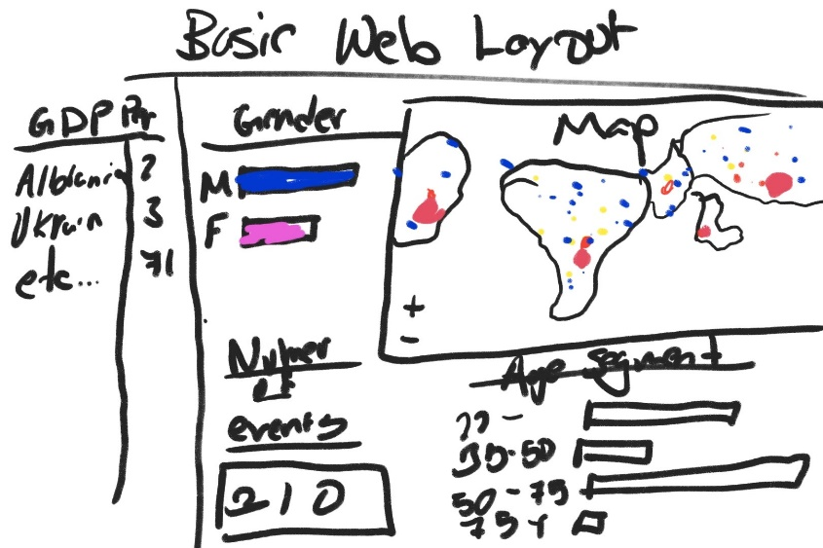

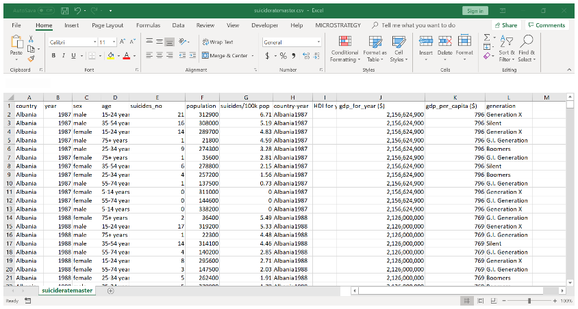

**Link of the Dataset being used:**

https://www.kaggle.com/russellyates88/suicide-rates-overview-1985-to-2016/version/1#master.csv